Bequest Guide and Codicil Form

When making your bequest, you may wish to adopt the following or similar wording:

For a gift in your Will of money
I wish to give the sum of money $.......or a percentage of my estate........%, (whatever is appropriate) free of all duties, to Women For Women In Africa for the general purposes to be utilised to support the education of children in Kibera.
For a gift in your Will of shares, insurance policy, works of art, property
I wish to give the following shares...............,insurance policy....................., works of art..................., property .......................,(whatever is appropriate), free of all duties,
to Women For Women In Africa for the general purposes to be utilised to support the education of children in Kibera.
For a gift in your Will for a specific purpose
I wish to give the following gift in my Will …………………………………..free of all duties, to Women For Women In Africa for the specific purpose……………………… ………….………………………………..to support the education of children in Kibera.

When making a gift in your Will it is highly advisable to consult with a legal advisor and discuss your gift with members of your immediate family.
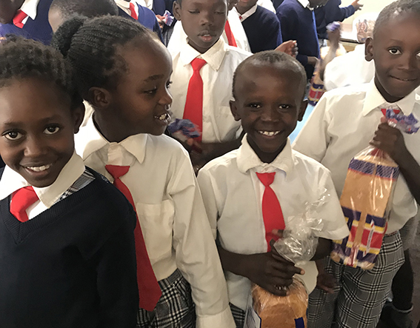
CODICIL FORM

Adding to an existing Will
If you have a Will it is relatively straightforward to include a bequest to WFWIA by completing this Codicil Form or a similar Codicil Form provided by your solicitor.

This Codicil Form, completed by you, the testator, must be witnessed at the same time by two persons who must not be related to you in any way and who are not mentioned in your Will as beneficiaries or executors.
When completed, include this Codicil Form with your original Will.

I, (full name).............................................................................................................................................
of (address)...............................................................................................................................................
Declare this to be a Codicil of my Will that is dated (date of your original Will).....................................

I give to Women For Women In Africa
..................................................................................................................................................................

..................................................................................................................................................................

..................................................................................................................................................................

In all other respects I confirm my Will
Signed by you, the testator, in the presence and attested by two witnesses both in the presence of the testator and each other.

Signature of testator..............................................................................
Today’s Date.........................................................................................

Witnessed by the following persons who have signed their names in the presence of each other and of the testator named above

Name of Witness……………………………………………………...
Occupation.............................................................................................
Address ………………………………………………........................
………………………………………………………………………..
Today’s Date……………………………………………………………
Signature..................................................................................................

Name of Witness……………………………………………………..
.Occupation..........................................................................................
Address …………………………………………...............................
……………………………………………………………………….
Today’s Date………………………………………………………..
Signature..............................................................................................

