THANK YOU!
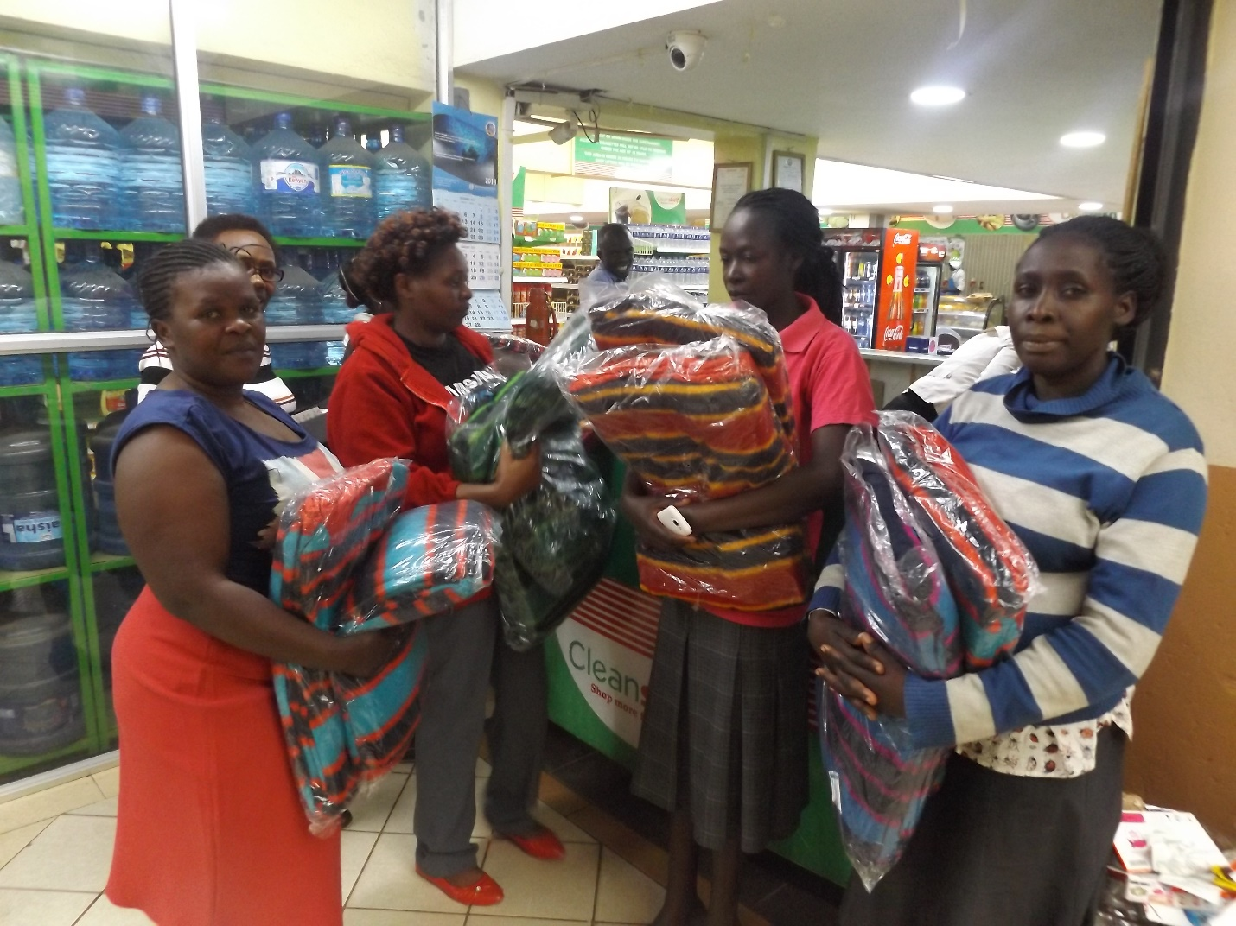
It has been several days of sorrow and sadness for most families who were affected by recent raging fire. The fire that gutted down over 500 houses and left over 6000 both children, men and women homeless in the Kijiji slum. Several families that we support were seriously affected. They also slept in the cold with less food to eat, no clean water to drink and few clothes to change. All these problems came to a BEAUTIFUL end yesterday on Monday the 12th 2018.
The good people of Australia heard the voices of these suffering children, men and women. The families that we care for have received help and lots of it. THANKS to the generosity of all the individuals, institutions, and families in Australia. The Affected families received food staff. Lots of maize and beans, oil, sugar, salt, milk, wheat flour, bread, and rice.
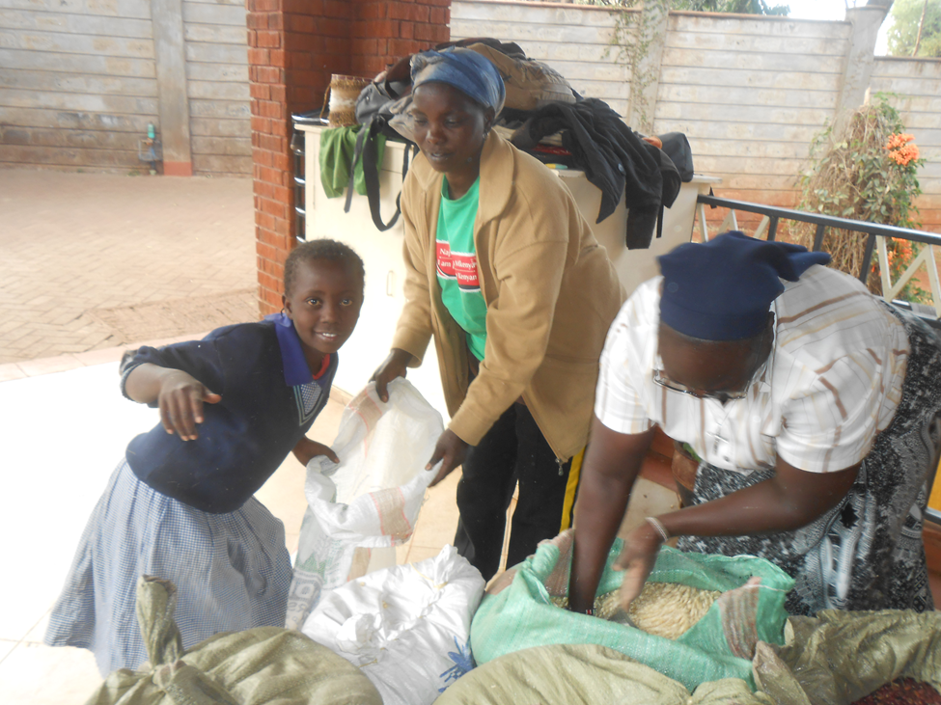
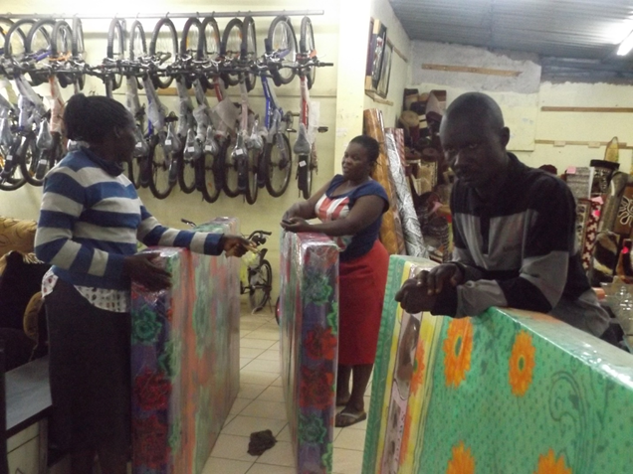
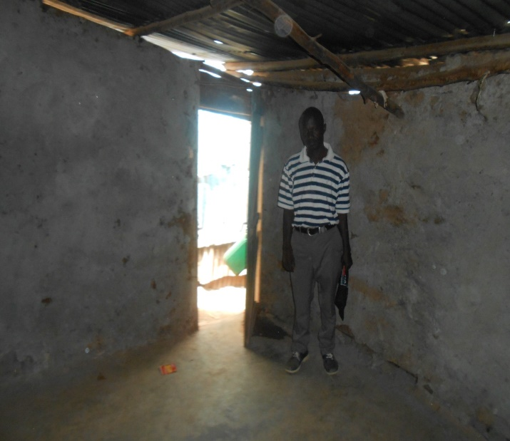
The affected families also moved into new houses and one month rent was paid for each of them. They received household items. These included mattresses, blankets, utensils and cutleries. They also got money to buy new clothes and the young children also got money for clothes and school uniform. Knickers too became useful when settling these families. It was so wonderful!
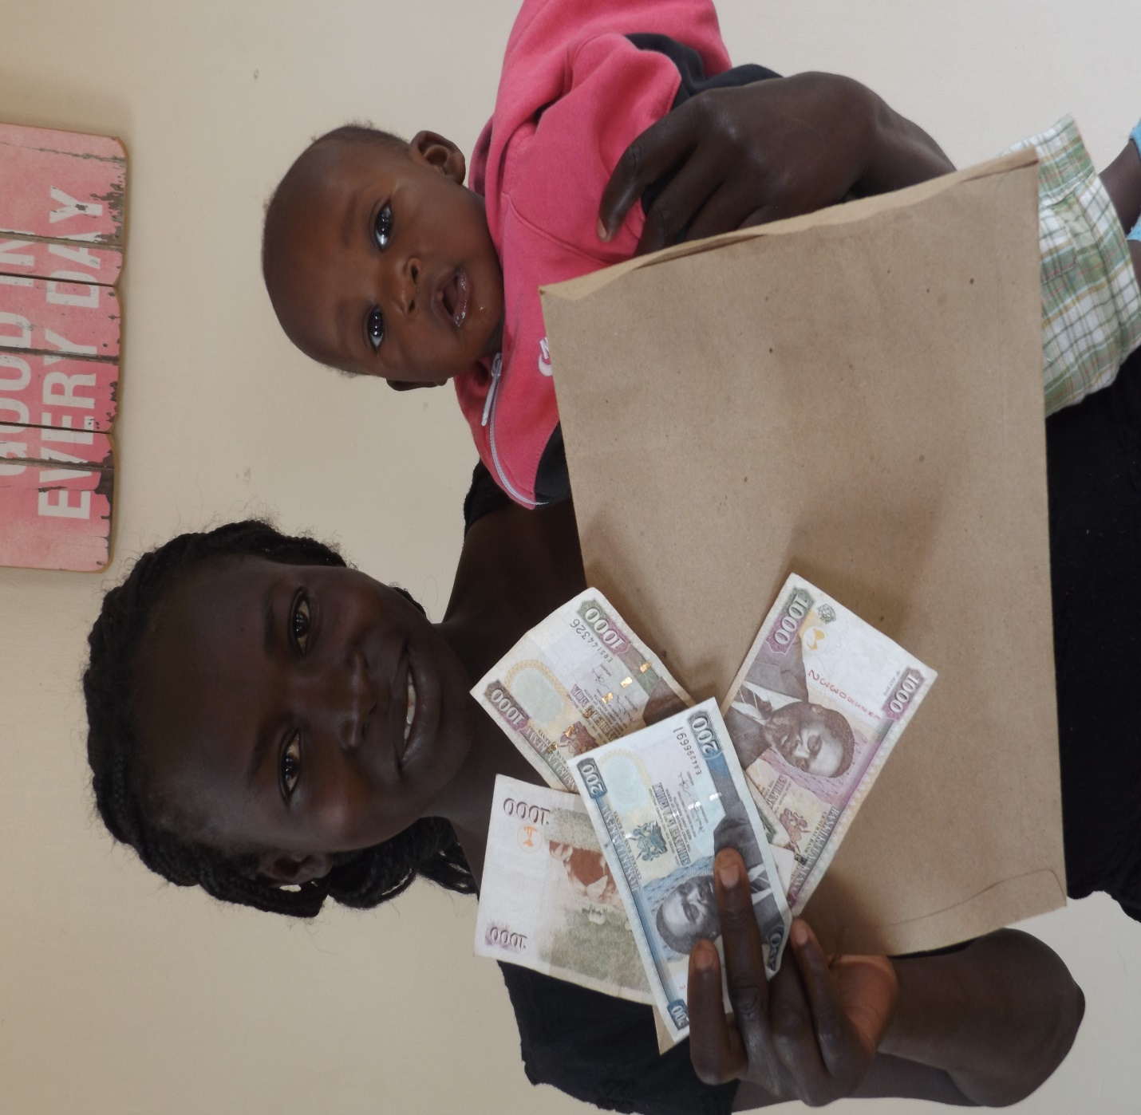

Thank you ALL dear friends. People from Mount Beauty Unity Church- Thank you so much, Chris, Meredith, Haddon and all your dear friends and families who donated so that these individuals may get helped-Thank you too. Anny, Joseph, Lola, Noel and all the people, families and friends who courageously and big-heartedly donated so that these families may again live in dignity and hope. Thank you all. To you Marguerite and your family, and Michael and Mandy. Thank you so much.
The affected families and the WkW (K) Organization at large would like to express their deepest and most sincere gratitude to everybody in Australia who contributed in one way or the other to make this mission possible. Thank you all !!!

Here is a “Thank you” letter from Mercyline Adhiambo. She is the mother to Cynthia Achieng. Cynthia is sponsored by Rae and Cam Thomson.
(I would try to remain faithful to the original text)
Dear Madam, sir
First, I would like to start by greeting you. How are you?
I hope you are fine. I am Cynthia Achieng’s Mother. It was on Sunday night on 28/01/2018. At that time I was coming from the shop when I heard people shouting Fire! Fire! I was so shocked because I had left my baby asleep in the house. I ran faster to save my boy who was so asleep by that time. It was a big fire which we could not afford to put out.
When fire extinguisher arrived, they found the fire had already covered the whole area. We tried to remove our things but all we tried to save by removing got stolen.
The fire began at 7 pm up to midnight. It was a bad day. A day I have never witnessed before. I am very lucky because my little boy and I are alive. I lost my best friend on that day. After the fire was put out, we were all stressed because we did not know what to do next. People were so hopeless but we thank God there is a primary school nearby where we slept. The next day it was on Monday, the Red-Cross brought us cooked food. We have been sleeping in the school from that Sunday to date. But I thank God who brought Women for Women Organization to Langata Otiende. It was on Friday 2/2/2018 when we came to form one meeting. We were told that we shall get some help. I was so happy because I felt like I can recover again from what had happened
I am really thanking Women for Women because they have brought light in my house. I am thanking them for what I have received. I am thanking them for food, clothes, money for rent.
God Help you a lot for what you have done for me. I was so stressed up, I have gotten rent, food and clothes.
Thanks a lot
Yours Mercyline Adhiambo

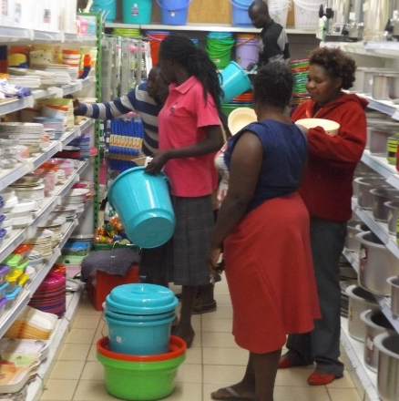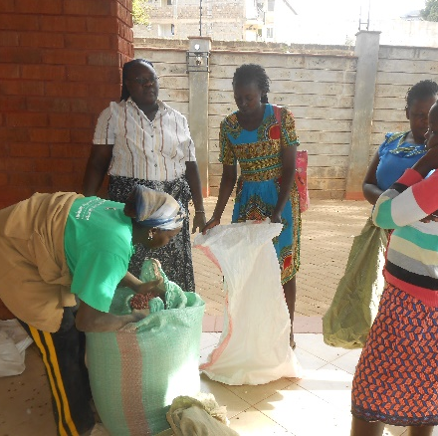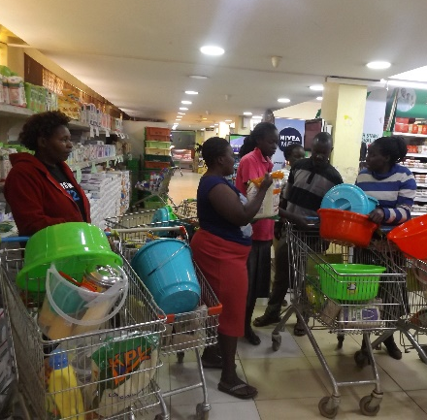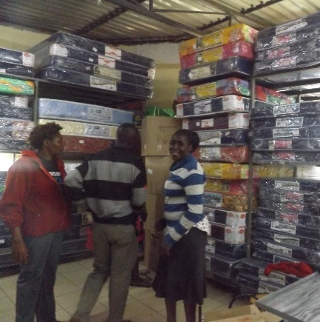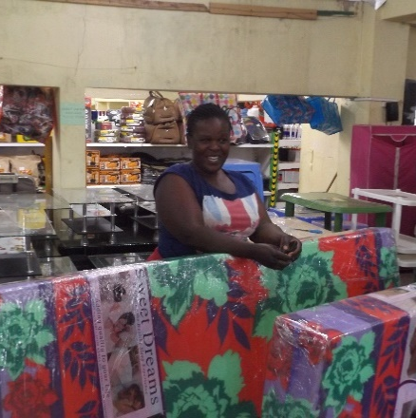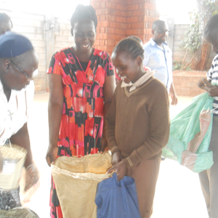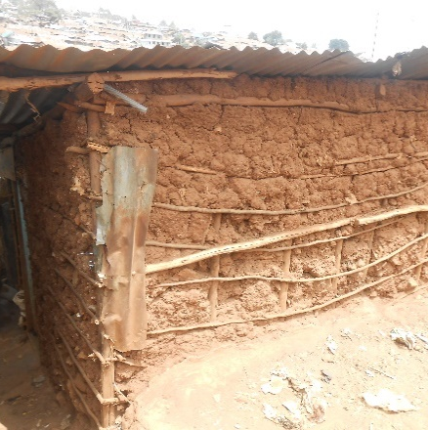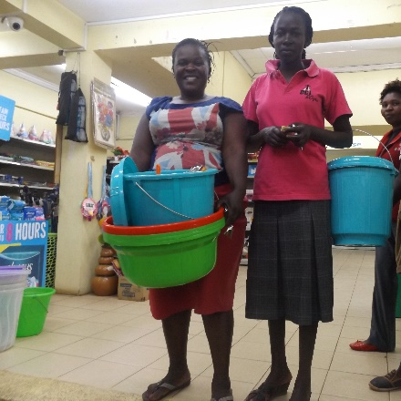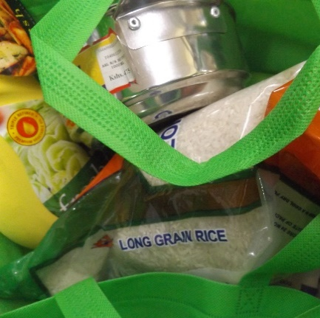

Conclusion
The Organization has journeyed with the affected families since the fire destroyed everything which they have ever worked for. This mission has been made possible because our sponsors and donors in Australia quickly responded to the plights of these poor families at the margins. Thank you again. WkW Organization has used a total of $2436.57 Australian Dollars in providing and settling our families who were affected by fire. The money has not been exhausted because the families have all been settled and they are happy and some money are remaining. The remaining Money will be used when their children comeback from school for April holidays. Some money will also be kept as special Fund called disaster fund so that in case a family get affected by fire or flooding or any other disaster in the future, we can easily respond to them.
Thank you
The organization has journeyed with the effected families since the fire destroyed everything that they have ever worked for. This mission has been made possible because our sponsors and donors in Australia quickly responded to the plights of these poor families. Thank you again. WkW Organization has used a total of … Australia Dollars. The money has not been used completely because the six families have all been settled and they are happy and some money are remaining. The remaining Money will be used when the children comeback from school for April holidays. Some money will also be kept as disaster fund so that incase a family get affected by fire or flooding or any other disaster, we can easily respond to them
Thank you

